The Department of Physics, Chemistry and Biology

Master thesis work

Simulating Ocean Waves and Ships with an Octree Data Structure

Kristofer Krus
Master thesis work carried out at Saab AB
May 28, 2012

LITH-IFM-x-EX--12/xxxx—SE

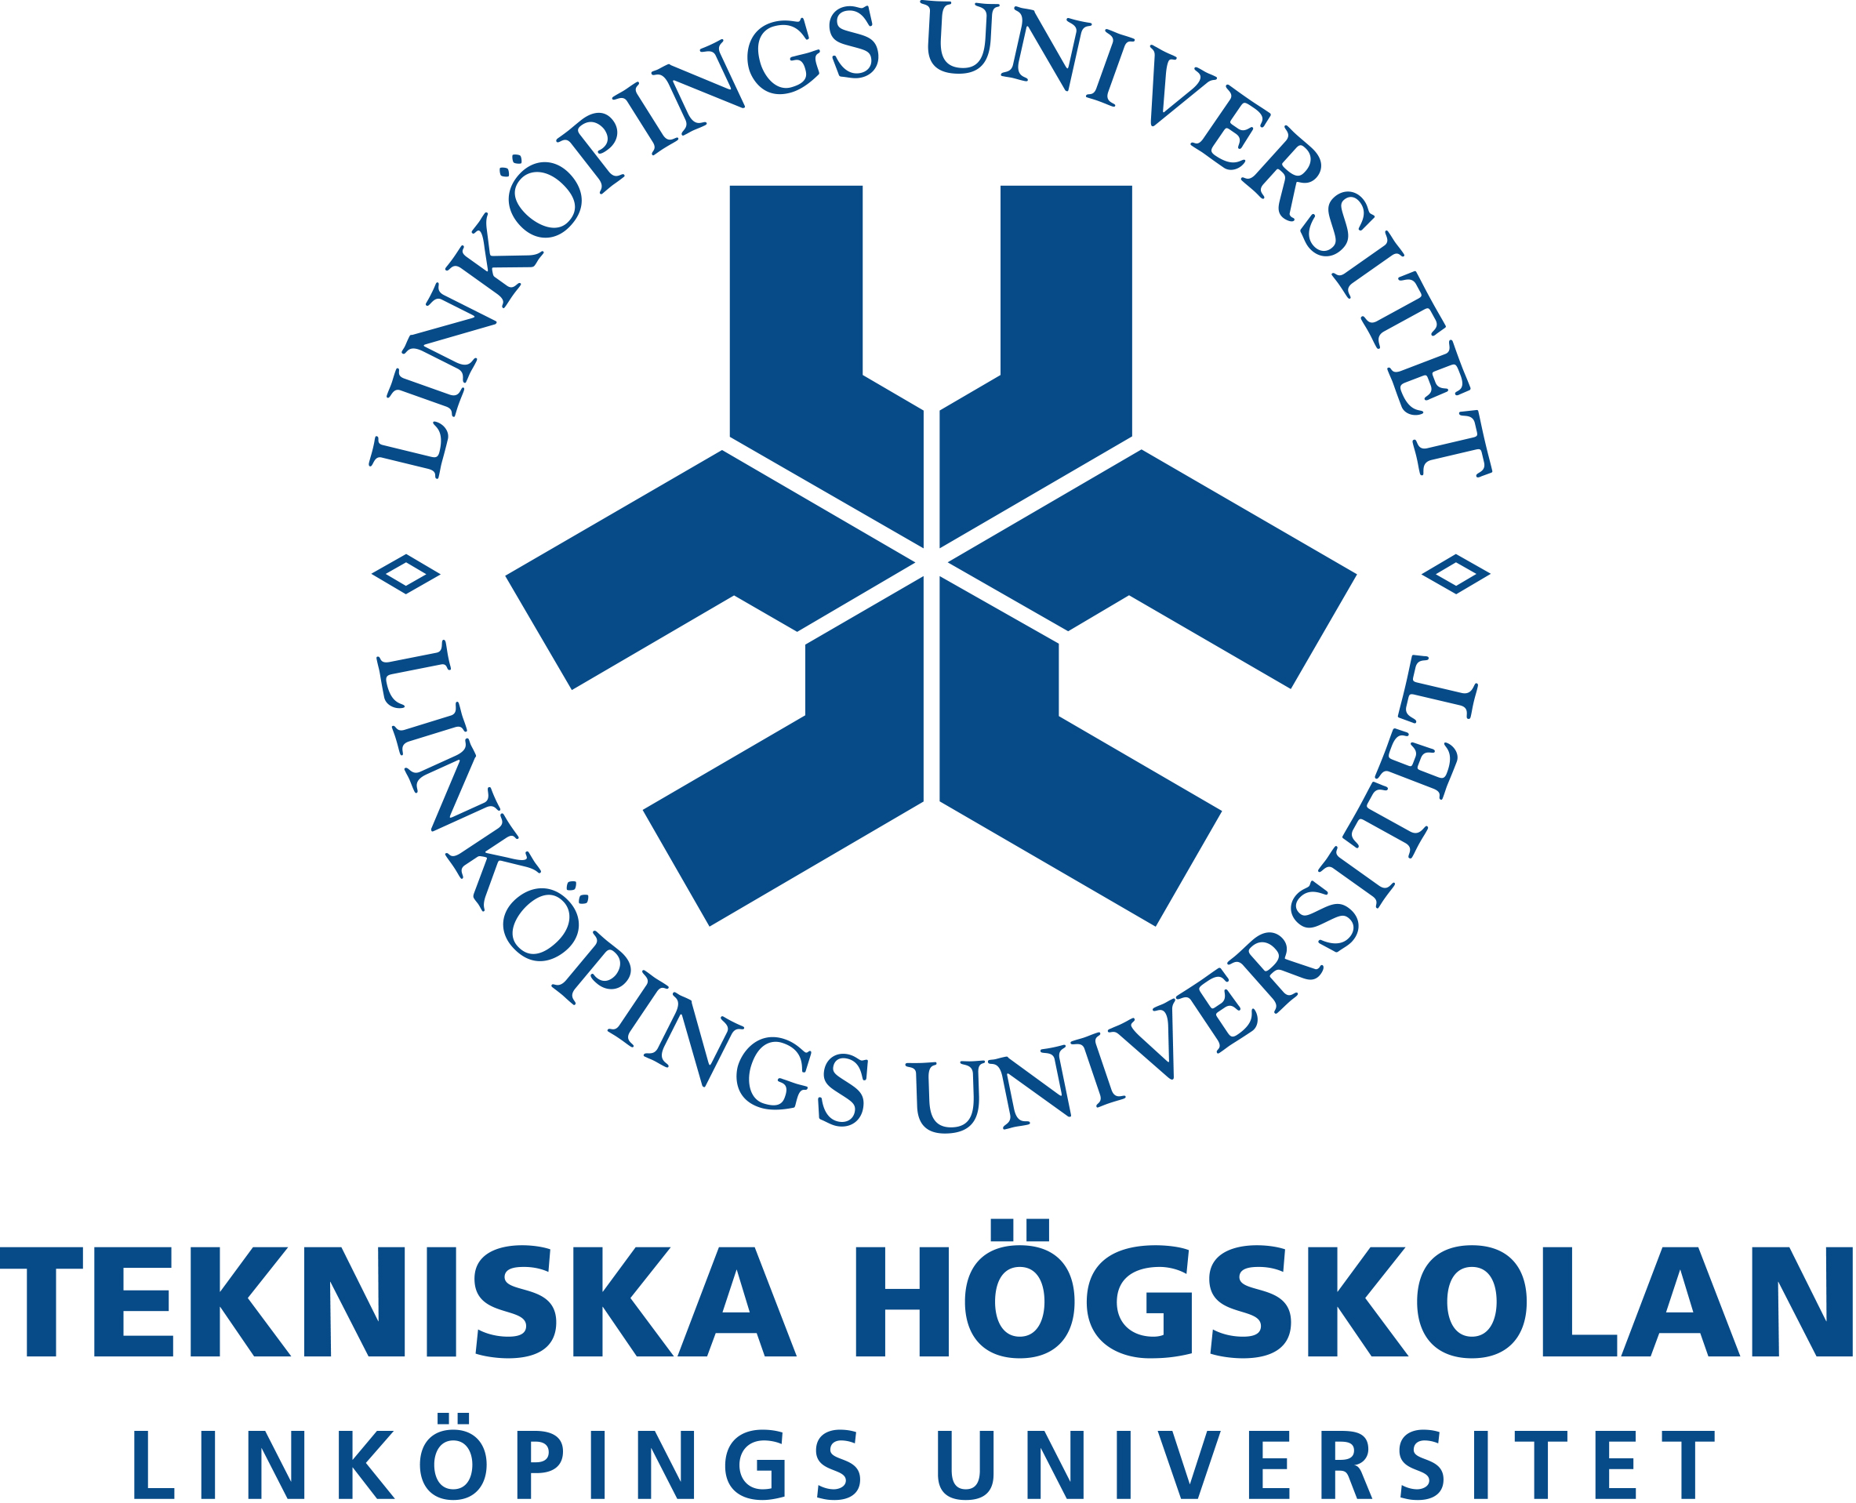

Linköping University the Department of Physics, Chemistry and Biology
581 83 Linköping
The Department of Physics, Chemistry and Biology

Simulating Ocean Waves and Ships with an Octree Data Structure

Kristofer Krus

Master thesis work carried out at Saab AB

May 28, 2012

Supervisors
Anders Rönnbrant (Saab AB)
Kenneth Järrendal (Linköping Institute of Technology)

Examinor
Magnus Johansson (Linköping Institute of Technology)

